SOFE 3490: Software Project Management



Lab 3

**Course Project:** 3-D scanning and 3-D Printing

**John Paul Polvorosa**

**#100553007**

**Software Project Estimation**

To calculate the estimated effort for our project and the duration in weeks, we are using the COCOMO model. For this model, we will be using Organic constants for the calculation. This is because we have the project domain that are related to previous works. In addition, the team members are already knowledgeable of the development techniques and they have sufficient experience with the technology being used.

COCOMO calculations below:

E = a(KLOC)^b, E is effort calculated in person months

D = c(E)^d, D is the duration calculated in months

KLOC = Thousand lines of code.

Organic constants 🡺 a = 2.4, b = 1.05, c = 2.5, d = 0.38

The coding will be done both in the hardware of the 3-d printer and also in other devices. Existing libraries that are capable of 3-d scanning and 3-d printing are previously solved problems. Built in hardware ~ 4000 LOC, Desktop, ~1000 LOC.

Therefore,

E = 2.4*(5)^1.05 🡺 13 months

D = 2.5*(13)^0.38 🡺 6.6 months

This translate to, project estimation will take 6.6 months with effort of 13 person months.

**Activity Planning**

**Activity Table shown below:**

|  |  |  |
| --- | --- | --- |
| **Task** | **Estimated Start** | **Task Duration** |
| Acquire Hardware (scanners, printers, CPU) | Week 0 | 3 week |
| Implement software compatibility between selected hardware and Assembly | Week 0 | 4 weeks |
| Staff Recruitment | Week 0 | 1 week |
| Create User Manual | Week 4 | 1 week |
| Coding | Week 5 | 15 weeks |
| Training | Week 20 | 1 week |
| Testing | Week 20 | 5 weeks |
| Documentation and finalization before distribution | Week 25 | 1 week |

**Activity Diagram shown below:**

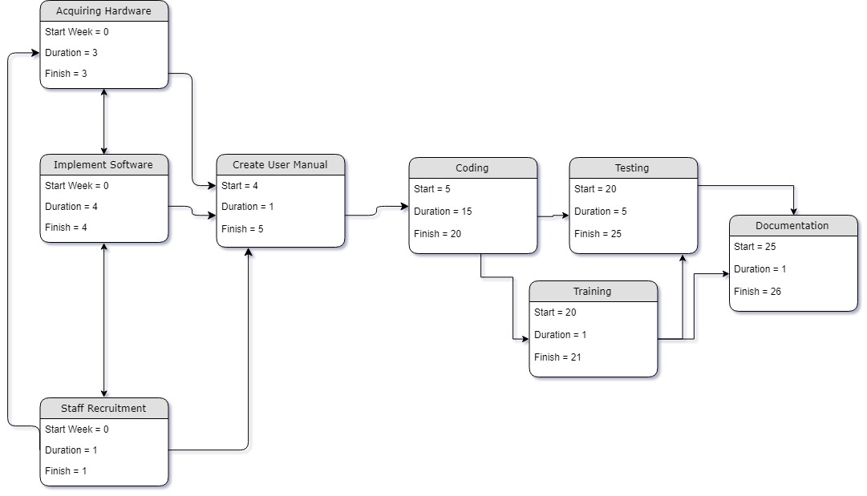

**Risk Management**

**Risks associated and Countermeasures in place to combat them**

1. Short staff recruitment duration
   1. Created a user manual to streamline the process within the project. So that everyone will be on the same page and will know their individual tasks after the hardware and software are all set up.
   2. With new hardware and software, existing online support are available for platforms chosen.
2. Risk of delayed release
   1. Strict deadlines are in place to ensure that staff are always coherent with the schedule
   2. Implement some flexibility and rotations within team, in case one person has more specialized skill than the other staff members
3. Risk of hardware errors
   1. Included in the user manual, is the system in place to ensure that critical work path is unaffected by hardware issues. This means that developers can still code outside of the hardware in place.
4. Short allocated training time
   1. While this may look short at first glance, real training occurs during the coding phase. This training phase at the end is more of a task that will train everyone in different roles and what each member has learned for their assigned tasks. This will enable each staff member in the future to be capable of doing other tasks when other ‘specialized’ staff are away.

**Resources:**

<https://www.geeksforgeeks.org/software-engineering-cocomo-model/>

**Lecture Slides:**

Chapter 6

Chapter 5

**Tutorial:**

Week 5